GO Concurrency Patterns

Key concepts
- Process: An isolated running program with its own virtual address space and OS resources.​
- Thread: A path of execution inside a process; threads of the same process share memory and other resources.
- Goroutine: A very lightweight, Go-managed execution unit that runs on top of OS threads, created with the go keyword
Key differences
1. Isolation and memory
- Process: Own address space, no shared memory with other processes by default; communication via IPC, sockets, etc.
- Thread: Shares memory and resources with other threads in the same process; easy but risky shared-state concurrency.
- Goroutine: Lives inside a Go process, multiplexed over a small pool of OS threads; shares heap with other goroutines but is managed by the Go runtime.
The Go proverb "Do not communicate by sharing memory; instead, share memory by communicating" promotes safe concurrency using channels over shared mutable state protected by locks.

Core Idea
Go's most famous design principle — "Do not communicate by sharing memory; instead, share memory by communicating." It means: instead of multiple goroutines reading/writing shared variables (with locks), you pass data through channels so only one goroutine "owns" the data at a time.

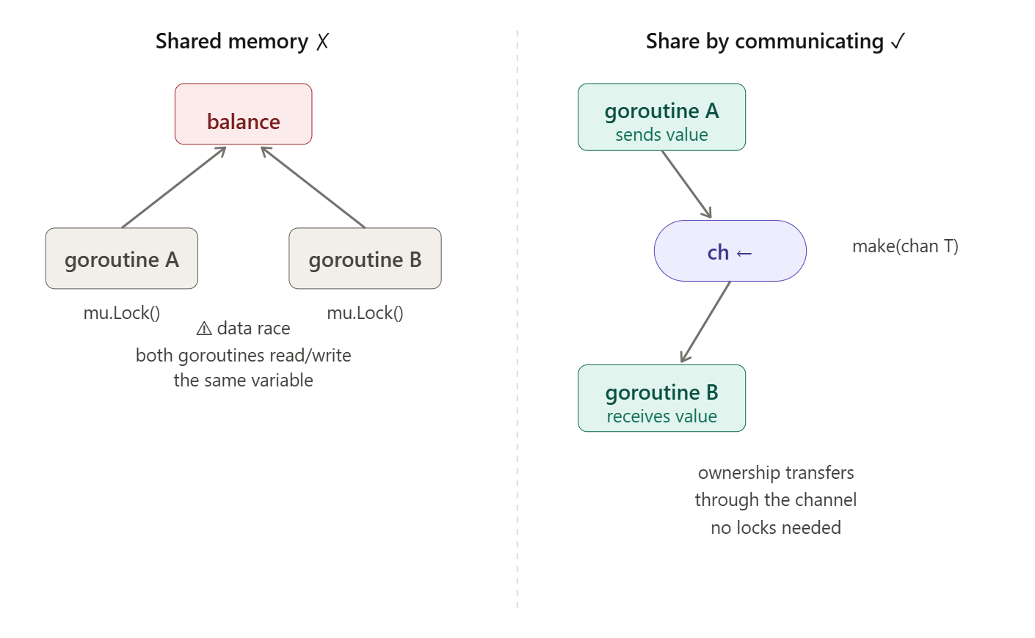

The mental model: Instead of thinking "all goroutines share a variable and I'll protect it with a lock," think "one goroutine owns the data, and others send it requests or results via channels." This is Go's implementation of CSP (Communicating Sequential Processes) — Tony Hoare's idea that concurrent safety comes from message-passing, not locking

1. Process vs thread vs goroutine
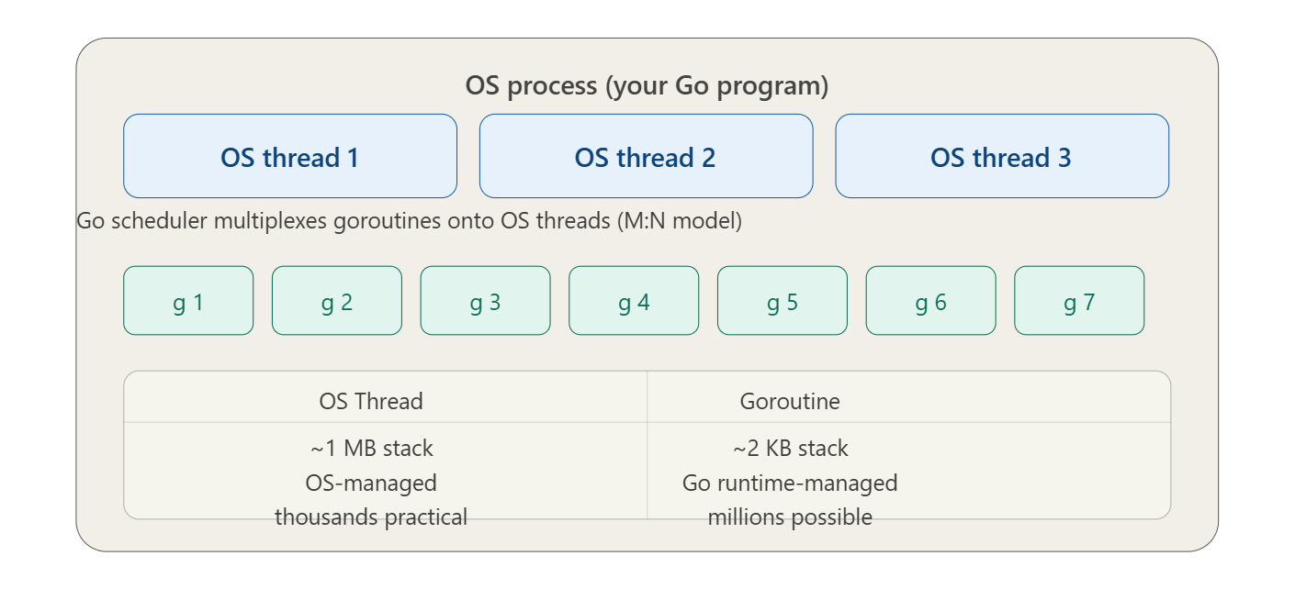
go routine has its own call stack is it true?
Yes, that is absolutely true. One of the reasons Go can handle thousands (or even millions) of goroutines simultaneously is how it manages these call stacks.
Here is the breakdown of how they work compared to traditional threads:
1. Dynamic Size (The "Small Start")
Unlike traditional OS threads which usually have a fixed, large stack (often 1MB or 2MB), a goroutine starts with a very small stack—typically only 2KB.
- Why? This tiny footprint allows you to spawn massive numbers of goroutines without exhausting your RAM.

2. Stack Growing and Shrinking
Because 2KB isn't much, Go has to be flexible.
- Growing: When a goroutine is about to exceed its current stack space (e.g., calling a deeply nested function), the Go runtime allocates a new, larger segment of memory and moves the stack there.
- Shrinking: If the goroutine finishes those intensive tasks and the stack is mostly empty, the runtime can shrink it back down to save memory.

3. Managed by the Runtime (Not the OS)
Traditional threads are managed by the Operating System. Goroutines are managed by the Go Runtime.
- The OS is "blind" to goroutines; it only sees the few OS threads that Go uses to multiplex all those goroutines.
- Because the Go runtime manages the stacks, it can move them around in memory efficiently—something an OS thread stack cannot do easily

Feature | OS Thread | Goroutine
Initial Stack Size | Fixed (~1-2MB) | Dynamic (~2KB)
Management | Operating System | Go Runtime
Creation Cost | Expensive (System call) | Very Cheap
Switching Cost | Slow (Context switch) | Fast (Scheduled by Go)

A Quick Clarification: Stack vs. Heap
While each goroutine has its own stack (for local variables and function calls), they all share the same heap. If a variable "escapes" the stack (for example, if a function returns a pointer to a local variable), that data is moved to the heap so other goroutines can potentially access it.

What about java threads vs go routines with respect to stack size?
The comparison between Java threads (Platform Threads) and Go routines is a classic study in memory efficiency. While both represent a path of execution, they handle their memory "budgets" very differently.
1. The Java Platform Thread (The "Heavyweight")
Traditionally, a Java thread is a thin wrapper around an Operating System (OS) thread.
- Fixed Stack Size: By default, a Java thread usually allocates 1MB for its stack (though this can be adjusted with the -Xss flag).
- The Problem with 1MB: Because the OS manages these threads, the memory must be allocated upfront and remain contiguous. If you have 1,000 threads, you've already spent 1GB of RAM just on stacks, even if those threads aren't doing anything.
- The "Wall": This is why Java applications often hit a "thread limit." You simply run out of memory if you try to spawn 100,000 threads.

2. The Go Routine (The "Lightweight")
Go routines are "user-space" threads managed by the Go runtime, not the OS.
- Segmented/Copying Stacks: A goroutine starts with a tiny stack of 2KB.
- Dynamic Growth: If a goroutine needs more space (e.g., deep recursion), the Go runtime creates a new, larger stack and copies the old data over. It can grow up to 1GB (on 64-bit systems), but it only uses what it needs right now.
- Efficiency: You can run millions of goroutines on a standard laptop because their combined initial memory footprint is negligible compared to Java's 1MB-per-thread rule
Feature | Java Platform Threads | Go Routines
Initial Stack Size | ~1MB (Large & Fixed) | ~2KB (Small & Dynamic)
Memory Limit | Harder to scale (RAM-heavy) | High scalability (Millions of units)
Scaling | Limited by OS resources | Limited by RAM availability
Management | OS Kernel | Go Runtime (M:N Scheduler)

A Note on Java "Project Loom" (Virtual Threads)
It is important to note that modern Java (Java 19+) introduced Virtual Threads.
- Virtual Threads act very similarly to Goroutines. They are "mounted" onto platform threads and have stacks that are stored in the heap rather than fixed OS memory.
- This allows Java to finally compete with Go's "millions of threads" model by moving away from the rigid 1MB fixed-stack requirement for high-concurrency tasks.
in case of java threads, when i create new thread what will happen with context of go routine ?
When you compare creating a Java Thread vs. a Go Routine, you are looking at two different levels of the "computer sandwich." Java (traditionally) creates something the Operating System manages, while Go creates something it manages itself.
Here is what happens when you create a new thread in both worlds:

1. Java (Platform) Thread: "Requesting a New House"
In traditional Java (pre-Virtual Threads), a thread is a Platform Thread.
- OS Intervention: When you call new Thread().start(), the JVM makes a system call to the Operating System (Linux, Windows, etc.).
- The "Heavy" Stack: The OS allocates a fixed block of memory—usually 1MB—for that thread's call stack immediately.
- The Link: There is a 1:1 relationship. 1 Java Thread = 1 OS Thread.
- Context Switching: Because the OS is in charge, switching between two Java threads requires a "Kernel Context Switch," which is expensive in terms of CPU cycles.

2. Go Routine: "Adding a Task to the List"
In Go, a goroutine is a User-space Thread.
- Internal Management: When you use the go keyword, the Go runtime handles it. The Operating System has no idea a new goroutine was even created.
- The "Light" Stack: Instead of 1MB, Go allocates a tiny 2KB stack.
- The "M:N" Model: Go uses an M:N scheduler. It takes $M$ goroutines and maps them onto $N$ OS threads (where $N$ is usually the number of CPU cores you have).
- Cheap Switching: If one goroutine stops (e.g., waiting for a channel), the Go scheduler simply swaps in another goroutine on that same OS thread. This happens in "User-space," meaning it's much faster than an OS context switch.

Action | Java (Platform Thread) | Go (Routine)
Who creates it? | The Operating System (Kernel) | The Go Runtime
Initial Memory | 1MB (Fixed) | 2KB (Dynamic)
Creation Speed | Slower (System call required) | Extremely Fast (Internal)
Maximum Count | Thousands (Limited by RAM) | Millions (Very scalable)
Context Switch | Heavy (Kernel level) | Light (User level)

is it main is running by a go routine?
Yes, absolutely. In Go, the main function is executed by a goroutine. We call this the Main Goroutine.
When your program starts, the Go runtime performs a few specific steps to get that first goroutine running:
1. The Birth of the Main Goroutine
The Go runtime is initialized first. Once it’s ready, it creates the very first goroutine and tasks it with running your main.main function.
2. The "Boss" Goroutine
The Main Goroutine is special because it controls the lifecycle of the entire program:
- Launching Others: Any other goroutines you start (using the go keyword) are "children" of this environment.
- The "Instant Exit" Rule: If the Main Goroutine finishes its work and returns, the entire program terminates immediately. It does not wait for other goroutines to finish unless you explicitly tell it to (using sync.WaitGroup or channels).

Comparison: Main Goroutine vs. Others
Feature | Main Goroutine | Any Other Goroutine (go func())
Created By | The Go Runtime at startup | The programmer using the go keyword
ID | Always 1 | Incrementing (2, 3, 4...)
Program Exit | If it dies, the program dies | Can die silently without stopping the program
Initial Stack | 2KB (Standard) | 2KB (Standard)

Goroutines — go keyword
Launching a goroutine is just the go keyword in front of a function call. The function runs concurrently — the caller doesn't wait.
package main
import (
"fmt"
"time"
)
func say(msg string) {
for i := 0; i < 3; i++ {
fmt.Println(msg)
time.Sleep(100 * time.Millisecond)
}
}
func main() {
go say("world") // runs concurrently
say("hello") // runs in main goroutine
}
The key problem: main() exiting kills all goroutines, even if they haven't finished. This is why we need sync.WaitGroup.

WaitGroup — waiting for goroutines to finish

sync.WaitGroup is a counter. You Add(n) before launching, each goroutine calls Done() when finished, and Wait() blocks until the counter hits zero.

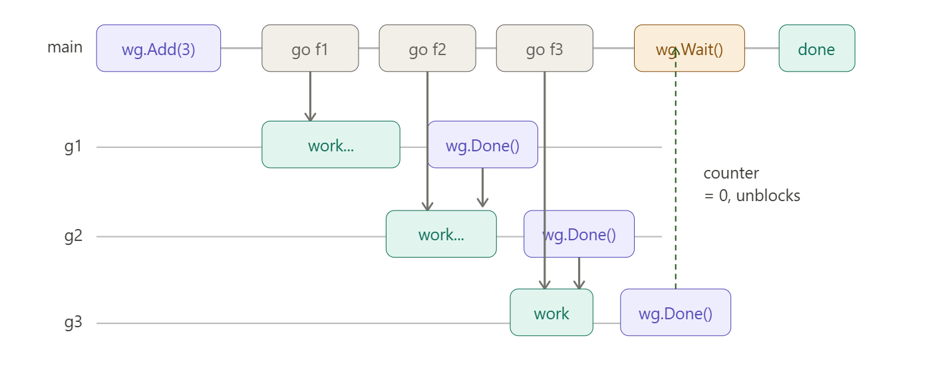
package main
import (
"fmt"
"sync"
)
func main() {
var wg sync.WaitGroup
for i := 0; i < 3; i++ {
wg.Add(1)
go func(id int) {
defer wg.Done() // Runs when goroutine exits
fmt.Printf("worker %d done\n", id)
}(i)
}
wg.Wait() // Blocks until counter == 0
fmt.Println("all workers finished")
}

This code demonstrates sync.WaitGroup for synchronizing multiple goroutines, ensuring the main goroutine waits for all workers to complete before printing the final message.

- var wg sync.WaitGroup creates a counter (starts at 0).
- wg.Add(1) increments counter by 1 before each goroutine starts (total: 3).
- go func(id int) launches 3 goroutines; i is captured explicitly to avoid shared variable bugs.
- defer wg.Done() decrements counter by 1 when each goroutine exits (even on panic).
- wg.Wait() blocks main goroutine until counter reaches 0 (all 3 Done() calls complete).
- Output order varies due to concurrent execution, but "all workers finished" always prints last.
Sample Output
text
worker 2 done
worker 0 done
worker 1 done
all workers finished
(Order unpredictable; goroutines race freely.)
Key Patterns
- Always Add() before go, Done() inside goroutine.
- Use defer wg.Done() for guaranteed cleanup.
- Pass loop variables (i) explicitly to goroutine closure.
- Common for worker pools, parallel tasks, resource cleanup.

Channels — the heart of Go concurrency
Channels are typed pipes. One goroutine sends a value in, another receives it out. By default, they're unbuffered — the sender blocks until a receiver is ready, and vice versa. This synchronization is the point.

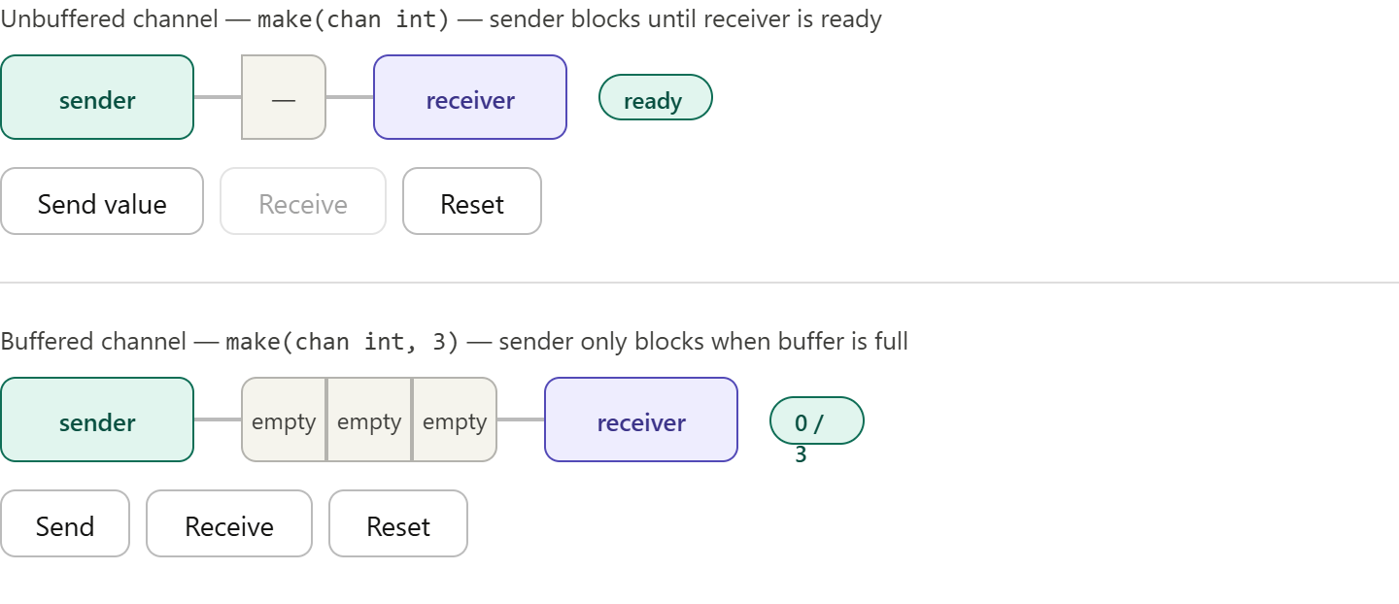

Unbuffered Example
package main
import (
"fmt"
"time"
)
func main() {
// Unbuffered channel - SYNCHRONOUS
fmt.Println("=== Unbuffered Channel ===")
ch := make(chan int)
go func() {
fmt.Println("Goroutine: sending 42...")
time.Sleep(10 * time.Second)
ch <- 42 // Blocks here until main receives
fmt.Println("Goroutine: send complete")
}()
fmt.Println("Main: waiting to receive...")
val := <-ch // Unblocks the sender goroutine
fmt.Println("Main received:", val) // 42
}

output:
=== Unbuffered Channel ===
Main: waiting to receive...
Goroutine: sending 42...
Goroutine: send complete
Main received: 42

Buffered:
package main
import (
"fmt"
)
func main() {
// Buffered channel - ASYNCHRONOUS (up to capacity)
fmt.Println("\n=== Buffered Channel (capacity 3) ===")
bch := make(chan int, 3)
fmt.Println("Sending 1 (no block)")
bch <- 1 // OK - buffer slot 1/3 used
fmt.Println("Sending 2 (no block)")
bch <- 2 // OK - buffer slot 2/3 used
fmt.Println("Sending 3 (no block)")
bch <- 3 // OK - buffer slot 3/3 used (full)
// bch <- 4 // This would BLOCK - buffer full!
fmt.Println("Buffer full, reading...")
fmt.Println("Received:", <-bch) // 1 (FIFO)
fmt.Println("Received:", <-bch) // 2
fmt.Println("Received:", <-bch) // 3
fmt.Println("Buffer empty now")
}
output:
=== Buffered Channel (capacity 3) ===
Sending 1 (no block)
Sending 2 (no block)
Sending 3 (no block)
Buffer full, reading...
Received: 1
Received: 2
Received: 3
Buffer empty now

Key Mental Model
Unbuffered: Sender ───┬─── Receiver (must meet simultaneously)
Buffered: Sender ───┤───[BUFFER]───┤─── Receiver (decoupled)
Use unbuffered for strict synchronization/handshakes.
Use buffered when producer/consumer speeds differ or to avoid immediate blocking.

select — waiting on multiple channels at once

select is like a switch but for channel operations. It picks whichever channel is ready first. If multiple are ready simultaneously, one is chosen at random.

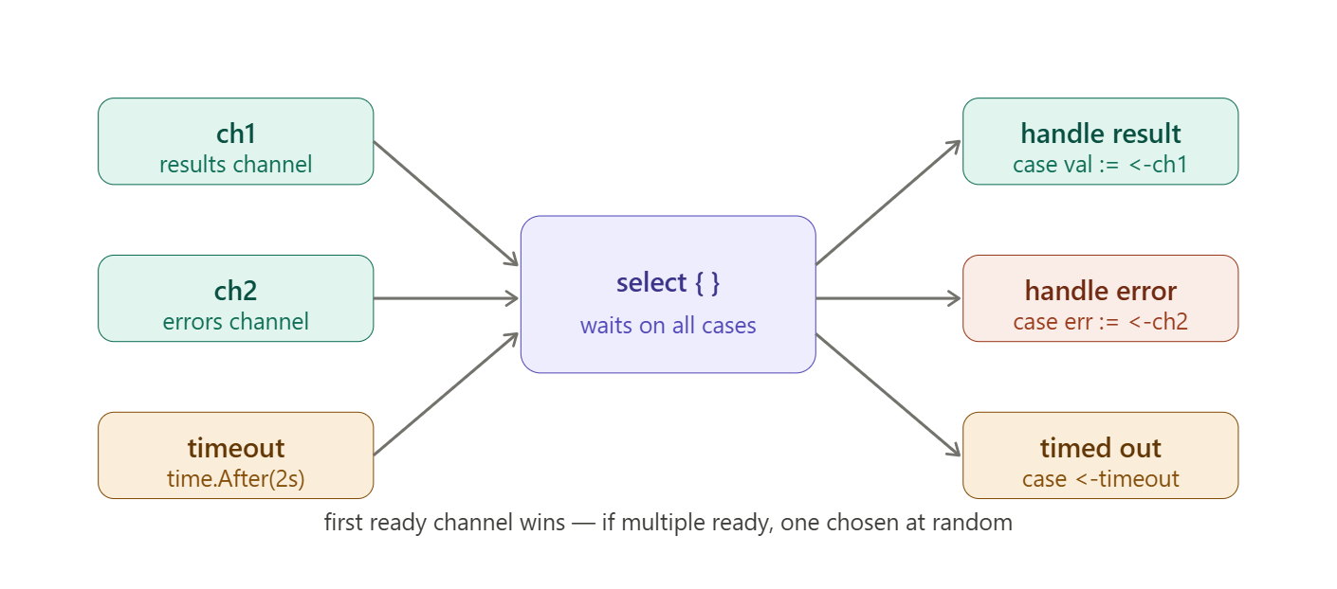

Code:

package main
import (
"fmt"
"time"
)
func main() {
// Create two channels
ch1 := make(chan int) // For results
ch2 := make(chan error) // For errors
// Simulate slow operations in goroutines
go func() {
time.Sleep(1 * time.Second) // Simulate work
ch1 <- 42 // Send result
}()
go func() {
time.Sleep(3 * time.Second) // Slower operation
ch2 <- fmt.Errorf("something failed")
}()
fmt.Println("Waiting for result, error, or timeout...")
select {
case val := <-ch1:
fmt.Println("got result:", val)
case err := <-ch2:
fmt.Println("got error:", err)
case <-time.After(2 * time.Second):
fmt.Println("timed out!")
}
fmt.Println("Continuing...")
}

Sample Output
Waiting for result, error, or timeout...
got result: 42
Continuing...
(ch1 wins because 1s < 2s timeout)

Key Patterns
- RPC timeouts: Wait for response or timeout
- Race between channels: Handle whichever finishes first
- Non-blocking coordination: Multiple goroutines signaling main
Mental model: select = "multiplexed <-ch with timeout + first-wins semantics"

Mutex — when you do need shared memory
Sometimes you genuinely need shared state (e.g. a cache, a counter). sync.Mutex protects it. Lock() acquires exclusive access, Unlock() releases it. Always pair them with defer.

Eg:
type SafeCounter struct {
mu sync.Mutex
count int
}

func (c *SafeCounter) Inc() {
c.mu.Lock()
defer c.mu.Unlock() // released when function returns
c.count++
}

func (c *SafeCounter) Value() int {
c.mu.Lock()
defer c.mu.Unlock()
return c.count
}

This code demonstrates a thread-safe counter using sync.Mutex to protect shared state from race conditions in concurrent Go programs.

type SafeCounter struct {
mu sync.Mutex // The lock that serializes access to `count`
count int // The shared state we need to protect
}

mu sync.Mutex - The mutex acts like a gate: only one goroutine can pass through (Lock()) at a time. Others wait in line.
count int - The critical section. Multiple goroutines reading/writing simultaneously would corrupt it.

Inc() - Atomic Increment
func (c *SafeCounter) Inc() {
c.mu.Lock() // 🔒 Acquire lock (blocks if already locked)
defer c.mu.Unlock() // 🔓 Auto-release when function exits
c.count++ // Safe: no other goroutine can access now
}

Execution flow:
- Lock() - If mutex free → take it. If locked → block this goroutine
- count++ executes exclusively
- Function returns → defer triggers → Unlock() releases
- Waiting goroutines wake up and compete for lock

Value() - Safe Read

func (c *SafeCounter) Value() int {
c.mu.Lock()
defer c.mu.Unlock()
return c.count // Safe snapshot of current value
}

Final code:

package main
import (
"fmt"
"sync"
)
type SafeCounter struct {
mu sync.Mutex
count int
}
func (c *SafeCounter) Inc() {
c.mu.Lock()
defer c.mu.Unlock()
c.count++
}
func (c *SafeCounter) Value() int {
c.mu.Lock()
defer c.mu.Unlock()
return c.count
}
func main() {
counter := SafeCounter{}
// Launch 1000 goroutines to increment concurrently
var wg sync.WaitGroup
for i := 0; i < 1000; i++ {
wg.Add(1)
go func() {
defer wg.Done()
counter.Inc() // Each increments safely
}()
}
wg.Wait()
fmt.Println("Final count:", counter.Value()) // Always 1000
}

Sample Output

Final count: 1000
(Predictable! Without mutex → random corruption like 847, 932, etc.)

Why defer c.mu.Unlock() is Critical
Without defer:
func (c *SafeCounter) Inc() {
c.mu.Lock()
c.count++ // What if panic here? ❌ DEADLOCK!
c.mu.Unlock()
}

With defer:
func (c *SafeCounter) Inc() {
c.mu.Lock()
defer c.mu.Unlock() // Guaranteed even on panic/return/break
c.count++
}

Mental Model: The Mutex Turnstile
Goroutine A: Inc() ──→ Lock() ──→ [CRITICAL SECTION: count++] ──→ Unlock()
Goroutine B: ──→ WAITS ──→ ──→ Runs next
Goroutine C: ──→ WAITS ──→ ──→ Waits...

Key rules:
- ✅ Always Lock before, Unlock after critical section
- ✅ defer Unlock() - foolproof cleanup
- ✅ Short critical sections - minimize blocking others
- ❌ Never forget Unlock() - causes deadlock
- ❌ Never Unlock() unowned mutex – panic

sync/atomic:

sync/atomic provides lock-free atomic operations for simple counters and flags. Much faster than mutexes for basic increment/read operations since no locking overhead.

Why Atomic > Mutex for Simple Counters

Mutex: Lock() → Critical Section → Unlock() [CONTENTION + OS calls]
Atomic: CPU instruction [single instruction, no contention]

Atomic Counter vs Mutex Counter

Mutex Version (Previous)

type SafeCounter struct {
mu sync.Mutex
count int
}
func (c *SafeCounter) Inc() { c.mu.Lock(); defer c.mu.Unlock(); c.count++ }

Atomic Version (Better for counters)
type AtomicCounter struct {
count atomic.Int32 // Or atomic.Uint64, etc.
}

func (c *AtomicCounter) Inc() {
c.count.Add(1) // Atomic increment
}

func (c *AtomicCounter) Value() int32 {
return c.count.Load() // Atomic read
}

Full code:

package main
import (
"fmt"
"sync"
"sync/atomic"
"time"
)
type AtomicCounter struct {
count atomic.Int64
}
func (c *AtomicCounter) Inc() { c.count.Add(1) }
func (c *AtomicCounter) Dec() { c.count.Add(-1) }
func (c *AtomicCounter) Value() int64 { return c.count.Load() }
// For comparison - Mutex version
type MutexCounter struct {
mu sync.Mutex
count int64
}
func (c *MutexCounter) Inc() {
c.mu.Lock()
defer c.mu.Unlock()
c.count++
}
func main() {
// Test atomic counter
fmt.Println("=== Atomic Counter ===")
ac := AtomicCounter{}
var wg sync.WaitGroup
start := time.Now()
for i := 0; i < 100000; i++ {
wg.Add(1)
go func() {
defer wg.Done()
ac.Inc()
}()
}
wg.Wait()
atomicDuration := time.Since(start)
fmt.Printf("Atomic: %d (took %v)\n", ac.Value(), atomicDuration)
// Test mutex counter
fmt.Println("\n=== Mutex Counter ===")
mc := MutexCounter{}
wg = sync.WaitGroup{}
start = time.Now()
for i := 0; i < 100000; i++ {
wg.Add(1)
go func() {
defer wg.Done()
mc.Inc()
}()
}
wg.Wait()
mutexDuration := time.Since(start)
fmt.Printf("Mutex: %d (took %v)\n", mc.count, mutexDuration)
fmt.Printf("\nAtomic is %.2fx faster\n", mutexDuration.Seconds()/atomicDuration.Seconds())
}

var (
counter atomic.Int64 // 64-bit signed integer
flag atomic.Bool // boolean
pointer atomic.Pointer[T] // generic pointer
)

// Operations:
counter.Add(1) // Atomic += 1
counter.Load() // Atomic read
counter.Store(42) // Atomic = 42
counter.CompareAndSwap(0, 1) // CAS: if ==0 then =1
flag.Store(true)
flag.Load()

When to Use Atomic vs Mutex vs Channels

Use Case | Pattern | Why
Simple counter | atomic.Int64 | Fastest, lock-free
Complex struct | sync.Mutex | Protects multiple fields
Producer/consumer | Channels | Go philosophy

RWMutex:

sync.RWMutex optimizes for read-heavy workloads - allows multiple readers simultaneously but exclusive writers.

Mutex vs RWMutex

Lock Type | Readers | Writers | Best For
Mutex | 1 at a time | 1 at a time | Write-heavy, simple
RWMutex | ∞ at once | 1 exclusive | Read-heavy (caches, configs)

rwmu := sync.RWMutex{}

// READERS (multiple OK)
rwmu.RLock() // Acquire shared read lock
rwmu.RUnlock() // Release read lock

// WRITERS (exclusive)
rwmu.Lock() // Acquire exclusive write lock
rwmu.Unlock() // Release write lock

API Methods
go
rwmu := sync.RWMutex{}

// READERS (multiple OK)
rwmu.RLock() // Acquire shared read lock
rwmu.RUnlock() // Release read lock

// WRITERS (exclusive)
rwmu.Lock() // Acquire exclusive write lock
rwmu.Unlock() // Release write lock
Full Working Code + Performance Demo
go
package main

import (
"fmt"
"sync"
"time"
)

type Cache struct {
mu sync.RWMutex
data map[string]int
}

func (c *Cache) Get(key string) (int, bool) {
c.mu.RLock() // Multiple readers OK
defer c.mu.RUnlock()
val, ok := c.data[key]
return val, ok
}

func (c *Cache) Set(key string, val int) {
c.mu.Lock() // Exclusive writer
defer c.mu.Unlock()
c.data[key] = val
}

func main() {
cache := &Cache{data: make(map[string]int)}

// Simulate read-heavy workload (90% reads)
var wg sync.WaitGroup

// 90 reader goroutines
for i := 0; i < 90; i++ {
wg.Add(1)
go func(id int) {
defer wg.Done()
for j := 0; j < 1000; j++ {
cache.Get("key") // Fast - multiple readers
}
}(i)
}

// 10 writer goroutines (rare)
for i := 0; i < 10; i++ {
wg.Add(1)
go func(id int) {
defer wg.Done()
time.Sleep(10 * time.Millisecond) // Simulate slow writes
cache.Set("key", id)
}(i)
}

start := time.Now()
wg.Wait()
fmt.Printf("RWMutex: %d readers + %d writers took %v\n", 90, 10, time.Since(start))
}
Mental Model: Library Rules
text
RWMutex = Public Library
- RLock() = Enter reading room (∞ seats)
- Lock() = Reserve entire library (exclusive)
- Readers can read together, writers kick everyone out
RWMutex vs Mutex Performance (typical)
text
Read-Heavy (90% read):
RWMutex: 45ms ← Multiple readers fly
Mutex: 320ms ← Readers queue up

Write-Heavy (90% write):
RWMutex: 180ms ← Writer overhead
Mutex: 150ms ← Simpler

Eg:
package main
import (
"fmt"
"sync"
"time"
)
type Cache struct {
mu sync.RWMutex
data map[string]int
}
func (c *Cache) Get(key string) (int, bool) {
c.mu.RLock() // Multiple readers OK
defer c.mu.RUnlock()
val, ok := c.data[key]
return val, ok
}
func (c *Cache) Set(key string, val int) {
c.mu.Lock() // Exclusive writer
defer c.mu.Unlock()
c.data[key] = val
}
func main() {
cache := &Cache{data: make(map[string]int)}
// Simulate read-heavy workload (90% reads)
var wg sync.WaitGroup
// 90 reader goroutines
for i := 0; i < 90; i++ {
wg.Add(1)
go func(id int) {
defer wg.Done()
for j := 0; j < 1000; j++ {
cache.Get("key") // Fast - multiple readers
}
}(i)
}
// 10 writer goroutines (rare)
for i := 0; i < 10; i++ {
wg.Add(1)
go func(id int) {
defer wg.Done()
time.Sleep(10 * time.Millisecond) // Simulate slow writes
cache.Set("key", id)
}(i)
}
start := time.Now()
wg.Wait()
fmt.Printf("RWMutex: %d readers + %d writers took %v\n", 90, 10, time.Since(start))
}

Let's walk through this code piece by piece.
The Cache struct
go
type Cache struct {
mu sync.RWMutex
data map[string]int
}
Two fields: a RWMutex that guards the map, and the map itself. The mutex and the data it protects live together in the same struct — this is the standard Go pattern. Nobody touches data without going through mu.

The Get method — shared read lock
go
func (c *Cache) Get(key string) (int, bool) {
c.mu.RLock()
defer c.mu.RUnlock()
val, ok := c.data[key]
return val, ok
}
RLock() says "I only want to read — let other readers in too." Any number of goroutines can hold RLock simultaneously. The defer guarantees RUnlock() runs no matter what — even if something panics. The map lookup happens inside the lock, then both the value and the ok boolean are returned.

The Set method — exclusive write lock
go
func (c *Cache) Set(key string, val int) {
c.mu.Lock()
defer c.mu.Unlock()
c.data[key] = val
}
Lock() is the full exclusive lock — it blocks until every reader and every other writer has finished. Only one goroutine can be inside Set at any moment. Everyone else waits outside.

main — the workload simulation
go
cache := &Cache{data: make(map[string]int)}
var wg sync.WaitGroup
Creates the cache and a WaitGroup to track all goroutines. make(map[string]int) is necessary — a nil map panics on write.
90 reader goroutines
go
for i := 0; i < 90; i++ {
wg.Add(1)
go func(id int) {
defer wg.Done()
for j := 0; j < 1000; j++ {
cache.Get("key")
}
}(i)
}
Each of the 90 goroutines calls Get 1,000 times — that's 90,000 read operations total. Because Get only holds RLock, many of these run in parallel at the same time.
10 writer goroutines
go
for i := 0; i < 10; i++ {
wg.Add(1)
go func(id int) {
defer wg.Done()
time.Sleep(10 * time.Millisecond)
cache.Set("key", id)
}(i)
}
Each writer sleeps 10ms first — simulating that writes are slow or infrequent in real life. Then it calls Set once. When a write happens, all current readers finish their Get, then the writer gets exclusive access, writes, and releases. Readers resume immediately after.
Timing and wait
go
start := time.Now()
wg.Wait()
fmt.Printf("RWMutex: %d readers + %d writers took %v\n", 90, 10, time.Since(start))
start is recorded before wg.Wait() — which blocks until all 100 goroutines call wg.Done(). The elapsed time is printed after.

What's actually happening concurrently

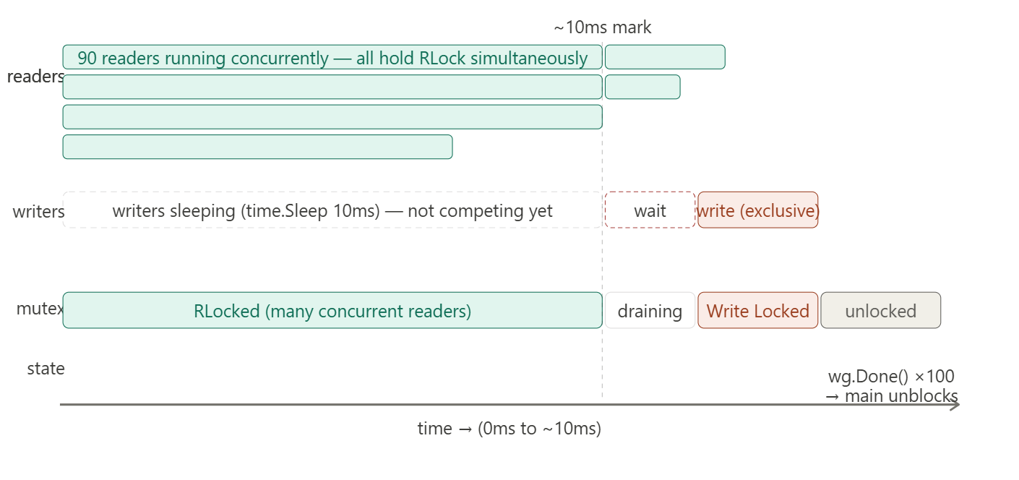

One subtle thing worth noticing
The id variable is passed as a parameter to the goroutine — go func(id int) { ... }(i). This is important. If you wrote it like this instead:
go
go func() {
cache.Set("key", i) // BUG: captures loop variable i by reference
}()
```

All goroutines would share the same `i`, and by the time they run, `i` is likely already `10`. Passing `i` as an argument copies the value at that moment, so each goroutine gets its own correct `id`. This is one of the most common goroutine bugs in Go.

---

## What the output tells you
```
RWMutex: 90 readers + 10 writers took 12.3ms

